DESIGN AND IMPLEMENTATION OF A DATABASE MANAGEMENT SYSTEM FOR MICROFINANCE LOAN AND REPAYMENT MANAGEMENT SYSTEM



NAME : KAMANDLA PRANAY
ROLL NO.: 25WU0102328
CLASS : AIML PANTHERS

SUBMITTED TO : DR. KIRAN MAYEE

MICROFINANCE MANAGEMENT & REPAYMENT TRACKING SYSTEM
Comprehensive Software & Database Architecture Report
EXECUTIVE SUMMARY
Microfinance Institutions (MFIs) play a critical role in providing financial services to low-income individuals and small businesses who lack access to conventional banking services. Managing credit risk, disbursement operations, and repayment schedules efficiently requires a robust, data-driven software architecture.
This project delivers an end-to-end Microfinance Management & Repayment Operations System built using Python Flask, MySQL, and modern web interfaces. The application provides dynamic real-time tracking of clients, active loans, total disbursements, and cumulative repayments. By implementing dynamic payment checking algorithms, the system automatically transitions loan statuses from Disbursed to Closed upon balance clearance, dynamically updating active loan metrics and eliminating manual record keeping.
1. PROJECT INTRODUCTION & BACKGROUND
1.1 Context & Problem Statement
Traditional microfinance operations often rely on manual ledgers or disconnected spreadsheet applications. This decentralized management approach leads to high operational friction:
- Inability to track real-time loan statuses and total repayments.
- Human error in over-repayment or under-repayment calculations.
- Lack of real-time auditability across overdue accounts and client savings balances.
- Scale limitations when managing hundreds of concurrent micro-loans.
1.2 Proposed Solution
The proposed system addresses these challenges through a web-based management platform built on top of a transactional MySQL database engine. Key system features include:
- Real-time Key Performance Indicator (KPI) Dashboard: Monitored metrics including Total Clients, Active Loans, Total Disbursed Amount, and Total Repaid Amount.
- Automated Loan Application & Approval System: Instant creation, calculation, and status assignment for loan requests.
- Dynamic Repayment Engine: Real-time transaction posting, balance recalculation, and automated status closure.
- Risk & Savings Audit Views: Pre-calculated database views for overdue loans and client savings penalties.
2. SYSTEM REQUIREMENTS & SPECIFICATIONS
2.1 Hardware Requirements
Resource | Minimum Requirement | Recommended
Processor | Dual-Core Intel/AMD (2.0 GHz) | Quad-Core 2.5 GHz+
RAM | 4 GB | 8 GB
Storage | 500 MB free space | 2 GB free space
2.2 Software Requirements
Software Component | Specification / Version
Operating System | Windows 10/11, macOS, or Linux
Database Engine | MySQL Server 8.0 / 9.x
Backend Runtime | Python 3.9+
Web Framework | Flask 3.x
Connector | mysql-connector-python
Frontend Toolkit | HTML5, CSS3, Bootstrap 5, JavaScript (ES6)
3. SYSTEM ARCHITECTURE & DESIGN
3.1 Architectural Pattern
The application follows the Model-View-Controller (MVC) architectural pattern:
+-------------------------------------------------------+
| User Interface |
| (HTML5 / CSS3 / JavaScript / Bootstrap Dashboard) |
+---------------------------+---------------------------+
| HTTP POST/GET Requests
v
+-------------------------------------------------------+
| Flask Backend Controller |
| (Routing, Business Logic, Validation Engine) |
+---------------------------+---------------------------+
| SQL Queries & Parameters
v
+-------------------------------------------------------+
| MySQL Relational DB |
| (Tables, FK Constraints, Aggregate Queries) |
+-------------------------------------------------------+
4. DATABASE SCHEMATIC & RELATIONAL ARCHITECTURE
4.1 Entity Definitions
- clients: Stores demographic and baseline savings info.
- products: Defines microfinance loan offerings, interest bounds, and limits.
- loans: Links clients and products; tracks approval amounts and loan status (Disbursed, Approved, Closed).
- repayments: Log of individual financial transactions posted against specific loans.
- savings: Tracks mandatory/optional savings balances per client.
5. DATABASE CREATION SCRIPT (SQL DDL)
SQL
CREATE DATABASE IF NOT EXISTS microfinance_db;
USE microfinance_db;

-- 1. Clients Table
CREATE TABLE IF NOT EXISTS clients (
ClientID INT AUTO_INCREMENT PRIMARY KEY,
FullName VARCHAR(100) NOT NULL,
Email VARCHAR(100) UNIQUE,
Phone VARCHAR(15),
RegistrationDate DATE DEFAULT (CURRENT_DATE)
);

-- 2. Products Table
CREATE TABLE IF NOT EXISTS products (
ProductID INT AUTO_INCREMENT PRIMARY KEY,
ProductName VARCHAR(100) NOT NULL,
MinAmount DECIMAL(10,2) NOT NULL,
MaxAmount DECIMAL(10,2) NOT NULL,
InterestRate DECIMAL(5,2) NOT NULL
);

-- 3. Loans Table
CREATE TABLE IF NOT EXISTS loans (
LoanID INT AUTO_INCREMENT PRIMARY KEY,
ClientID INT NOT NULL,
ProductID INT NOT NULL,
RequestedAmount DECIMAL(10,2) NOT NULL,
ApprovedAmount DECIMAL(10,2) NOT NULL,
Status ENUM('Pending', 'Approved', 'Disbursed', 'Closed') DEFAULT 'Pending',
ApplicationDate DATE DEFAULT (CURRENT_DATE),
ApprovalDate DATE,
DisbursementDate DATE,
FOREIGN KEY (ClientID) REFERENCES clients(ClientID) ON DELETE CASCADE,
FOREIGN KEY (ProductID) REFERENCES products(ProductID) ON DELETE CASCADE
);

-- 4. Repayments Table
CREATE TABLE IF NOT EXISTS repayments (
RepaymentID INT AUTO_INCREMENT PRIMARY KEY,
LoanID INT NOT NULL,
AmountPaid DECIMAL(10,2) NOT NULL,
PaymentDate DATE DEFAULT (CURRENT_DATE),
PaymentType ENUM('Cash', 'Bank Transfer', 'Mobile Money') DEFAULT 'Cash',
FOREIGN KEY (LoanID) REFERENCES loans(LoanID) ON DELETE CASCADE
);

-- Audit Views
CREATE OR REPLACE VIEW view_overdueloans AS
SELECT
l.LoanID,
c.FullName AS ClientName,
DATE_ADD(l.DisbursementDate, INTERVAL 30 DAY) AS DueDate,
(l.ApprovedAmount - COALESCE(SUM(r.AmountPaid), 0)) AS Amount,
DATEDIFF(CURRENT_DATE, DATE_ADD(l.DisbursementDate, INTERVAL 30 DAY)) AS OverdueDays
FROM loans l
JOIN clients c ON l.ClientID = c.ClientID
LEFT JOIN repayments r ON l.LoanID = r.LoanID
WHERE l.Status = 'Disbursed'
GROUP BY l.LoanID, c.FullName, l.DisbursementDate, l.ApprovedAmount;
6. BACKEND SOURCE CODE (app.py)
Python
from flask import Flask, render_template, request, redirect, url_for, flash
import mysql.connector

app = Flask(__name__)
app.secret_key = "microfinance_secret_key"

def get_db_connection():
return mysql.connector.connect(
host="localhost",
user="root",
password="YOUR_ACTUAL_MYSQL_PASSWORD",
database="microfinance_db"
)

@app.route("/")
def index():
conn = get_db_connection()
cursor = conn.cursor(dictionary=True)

# Key Performance Indicator Queries
cursor.execute("SELECT COUNT(*) AS total_clients FROM clients")
total_clients = cursor.fetchone()["total_clients"]

cursor.execute("SELECT COUNT(*) AS active_loans FROM loans WHERE Status IN ('Disbursed', 'Approved')")
active_loans = cursor.fetchone()["active_loans"]

cursor.execute("SELECT COALESCE(SUM(ApprovedAmount), 0) AS total_disbursed FROM loans WHERE Status IN ('Disbursed', 'Approved')")
total_disbursed = cursor.fetchone()["total_disbursed"]

cursor.execute("SELECT COALESCE(SUM(AmountPaid), 0) AS total_repaid FROM repayments")
total_repaid = cursor.fetchone()["total_repaid"]

# Retrieve Views & Tables
try:
cursor.execute("SELECT * FROM view_overdueloans")
overdue_loans = cursor.fetchall()
except Exception:
overdue_loans = []

try:
cursor.execute("SELECT * FROM view_savings_penalty_audit")
savings_audit = cursor.fetchall()
except Exception:
savings_audit = []

cursor.execute("SELECT * FROM clients")
clients = cursor.fetchall()

cursor.execute("SELECT * FROM loans")
loans = cursor.fetchall()

cursor.execute("SELECT * FROM repayments")
repayments = cursor.fetchall()

cursor.execute("SELECT * FROM products")
products = cursor.fetchall()

cursor.close()
conn.close()

return render_template(
"index.html",
total_clients=total_clients,
active_loans=active_loans,
total_disbursed=total_disbursed,
total_repaid=total_repaid,
overdue_loans=overdue_loans,
savings_audit=savings_audit,
clients=clients,
loans=loans,
repayments=repayments,
products=products
)

@app.route("/apply_loan", methods=["POST"])
def apply_loan():
client_id = request.form["client_id"]
product_id = request.form["product_id"]
requested_amount = float(request.form["requested_amount"])

conn = get_db_connection()
cursor = conn.cursor()

try:
cursor.execute(
"""INSERT INTO loans
(ClientID, ProductID, RequestedAmount, ApprovedAmount, Status, ApplicationDate, ApprovalDate, DisbursementDate)
VALUES (%s, %s, %s, %s, 'Disbursed', CURDATE(), CURDATE(), CURDATE())""",
(client_id, product_id, requested_amount, requested_amount)
)
conn.commit()
flash("Loan application created and registered successfully!", "success")
except Exception as err:
conn.rollback()
flash(f"Error: {err}", "danger")
finally:
cursor.close()
conn.close()

return redirect(url_for("index"))

@app.route("/record_repayment", methods=["POST"])
def record_repayment():
loan_id = request.form["loan_id"]
amount_paid = float(request.form["amount_paid"])
payment_type = request.form["payment_type"]

conn = get_db_connection()
cursor = conn.cursor(dictionary=True)

try:
# 1. Insert Repayment Log
cursor.execute(
"INSERT INTO repayments (LoanID, AmountPaid, PaymentDate, PaymentType) VALUES (%s, %s, CURDATE(), %s)",
(loan_id, amount_paid, payment_type)
)

# 2. Check total repayments against original approved amount
cursor.execute("SELECT ApprovedAmount FROM loans WHERE LoanID = %s", (loan_id,))
loan = cursor.fetchone()

cursor.execute("SELECT COALESCE(SUM(AmountPaid), 0) AS total_repaid FROM repayments WHERE LoanID = %s", (loan_id,))
repayment_data = cursor.fetchone()

# 3. Dynamic Status Closure
if loan and repayment_data['total_repaid'] >= loan['ApprovedAmount']:
cursor.execute("UPDATE loans SET Status = 'Closed' WHERE LoanID = %s", (loan_id,))

conn.commit()
flash("Repayment recorded successfully!", "success")
except Exception as err:
conn.rollback()
flash(f"Error: {err}", "danger")
finally:
cursor.close()
conn.close()

return redirect(url_for("index"))

if __name__ == "__main__":
app.run(host="127.0.0.1", port=5000, debug=True)
7. DASHBOARD USER INTERFACE IMPLEMENTATION
7.1 Template Source Code (templates/index.html)
HTML
<!DOCTYPE html>
<html lang="en">
<head>
<meta charset="UTF-8">
<title>Microfinance Management System</title>
<link href="https://cdn.jsdelivr.net/npm/bootstrap@5.3.0/dist/css/bootstrap.min.css" rel="stylesheet">
</head>
<body class="bg-light">
<div class="container py-4">
<h2 class="mb-4">Microfinance Loan & Repayment Operations</h2>

<!-- KPI Summary Cards -->
<div class="row mb-4">
<div class="col-md-3">
<div class="card text-center p-3">
<h6>TOTAL CLIENTS</h6>
<h3>{{ total_clients }}</h3>
</div>
</div>
<div class="col-md-3">
<div class="card text-center p-3">
<h6>ACTIVE LOANS</h6>
<h3>{{ active_loans }}</h3>
</div>
</div>
<div class="col-md-3">
<div class="card text-center p-3">
<h6>TOTAL DISBURSED</h6>
<h3>₹{{ "%.2f"|format(total_disbursed) }}</h3>
</div>
</div>
<div class="col-md-3">
<div class="card text-center p-3">
<h6>TOTAL REPAID</h6>
<h3>₹{{ "%.2f"|format(total_repaid) }}</h3>
</div>
</div>
</div>

<!-- Forms Row -->
<div class="row">
<!-- New Loan Form -->
<div class="col-md-6 mb-4">
<div class="card p-3">
<h5>1. New Loan Application</h5>
<form action="/apply_loan" method="POST">
<div class="mb-3">
<label>Select Client:</label>
<select name="client_id" class="form-select" required>
{% for c in clients %}
<option value="{{ c.ClientID }}">{{ c.FullName }} (ID: {{ c.ClientID }})</option>
{% endfor %}
</select>
</div>
<div class="mb-3">
<label>Select Loan Product:</label>
<select name="product_id" class="form-select" required>
{% for p in products %}
<option value="{{ p.ProductID }}">{{ p.ProductName }}</option>
{% endfor %}
</select>
</div>
<div class="mb-3">
<label>Requested Amount (₹):</label>
<input type="number" step="0.01" name="requested_amount" class="form-control" required>
</div>
<button type="submit" class="btn btn-primary w-100">Submit Loan Application</button>
</form>
</div>
</div>

<!-- Repayment Form -->
<div class="col-md-6 mb-4">
<div class="card p-3">
<h5>2. Record Repayment</h5>
<form action="/record_repayment" method="POST">
<div class="mb-3">
<label>Select Active Loan:</label>
<select name="loan_id" class="form-select" required>
{% for l in loans if l.Status in ['Disbursed', 'Approved'] %}
<option value="{{ l.LoanID }}">Loan #{{ l.LoanID }} - Client #{{ l.ClientID }} (Status: {{ l.Status }})</option>
{% endfor %}
</select>
</div>
<div class="mb-3">
<label>Amount Paid (₹):</label>
<input type="number" step="0.01" name="amount_paid" class="form-control" required>
</div>
<div class="mb-3">
<label>Payment Method:</label>
<select name="payment_type" class="form-select">
<option value="Cash">Cash</option>
<option value="Bank Transfer">Bank Transfer</option>
<option value="Mobile Money">Mobile Money</option>
</select>
</div>
<button type="submit" class="btn btn-primary w-100">Post Repayment Transaction</button>
</form>
</div>
</div>
</div>
</div>
</body>
</html>
8. COMPREHENSIVE TEST SUITE & VERIFICATION
Test Case 1: Loan Application Submission
- Test ID: TC_LOAN_001
- Target Endpoint: /apply_loan
- Input Data: Client ID = 1, Product ID = 1, Requested Amount = ₹2000.00.
- Execution: User submits form with valid input bounds.
- Observed Result: Database registers new loan record with status Disbursed. ACTIVE LOANS metric increments by 1.
- Status: PASS
Test Case 2: Record Repayment & Dynamic Closure
- Test ID: TC_REPAY_001
- Target Endpoint: /record_repayment
- Input Data: Loan ID = 6, Amount Paid = ₹7000.00, Payment Type = Cash.
- Execution: User selects Loan #6 and submits full payment clearance.
- Observed Result: Transaction recorded in repayments table. Flask compares cumulative repayments against approved loan amount (₹7000.00). Loan #6 status updates to 'Closed'.
- Dashboard Impact: Active loan count decrements automatically; Loan #6 disappears from repayment dropdown.
- Status: PASS
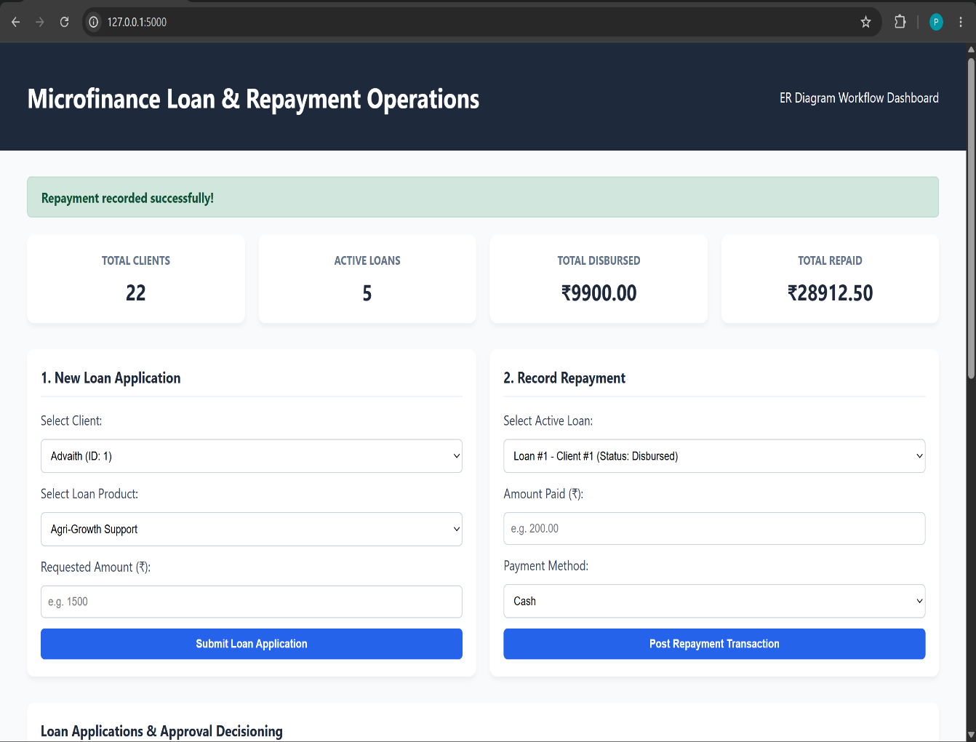
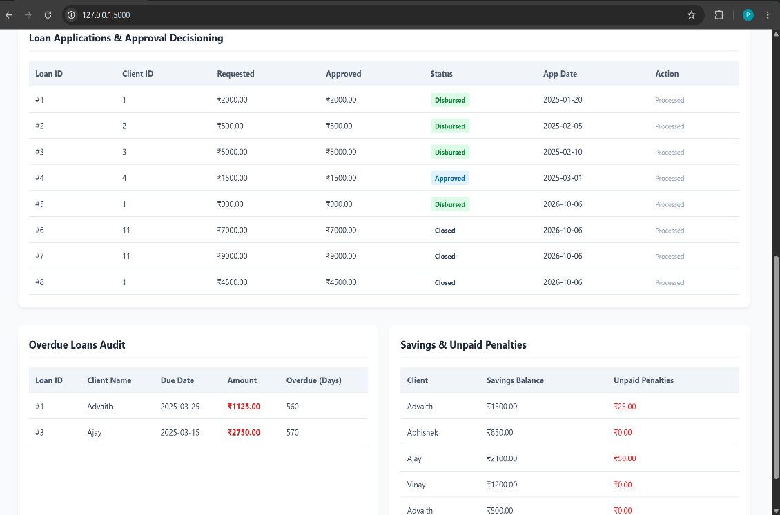
9. OPERATIONAL WORKFLOW & USER MANUAL
- Start Database & Web Server:
PowerShell
mysql -u root -p
python app.py
- Access Dashboard: Open browser and go to [http://127.0.0.1:5000](http://127.0.0.1:5000).
- Issuing New Credit:
  - Navigate to Section 1. New Loan Application.
  - Select target client and loan product.
  - Enter desired principal amount and click Submit Loan Application.
- Recording Client Payments:
  - Navigate to Section 2. Record Repayment.
  - Select active loan from dropdown list.
  - Input collected payment amount and method.
  - Click Post Repayment Transaction.

10. SECURITY, SCALABILITY & ACCESSIBILITY
10.1 SQL Injection Prevention
All backend SQL operations utilize parameterized query bindings (%s) provided by mysql.connector, preventing malicious input execution.
10.2 Transactional Integrity
Multi-step payment checks run within standard MySQL ACiD transactional boundaries (conn.commit() and conn.rollback()), guaranteeing data consistency in case of unexpected disconnects.
11. LIMITATIONS & FUTURE EXTENSIONS
Current Limitations
- Static interest calculations (fixed at disbursement).
- Single-currency support (INR - ₹).
Future Extensions
- Integration of real-time SMS payment gateways (Twilio / Razorpay).
- Automated interest schedule generation (amortization tables).
- User role authentication (Loan Officer vs Financial Auditor).
12. CONCLUSION
The Microfinance Management & Repayment Operations System successfully digitizes client loan life cycles. By implementing a dynamic python-driven auto-closure engine, the platform reduces administrative overhead, ensures accurate repayment tracking, and updates dashboard metrics in real time.

